San Giovanni Teatino 09/06/2025
Spett.le
FORKLIFT S.A.
6 AGIOU KONSTANTINOU STR. 10431
10431 GREECE
Località installazione / Destinazione Merce
ATENE

TECHNICAL AND COMMERCIAL PROPOSAL NO. CTS2506212522121/15

Following your kind request, we are hereby sending our. Best Quotation for the products listed below:
TENDO COPERTURA MOBILE COPRITUTTO® STANDARD CTS

External width mm. 20000
Maximum depth mm. 50000
Usable height mm. 6500
Front closure fixed curtain wall and/or sliding curtain
Rear closure fixed infill and/or sliding sheet
Left side closed with ground cover
Right side closed with a tarp on the ground
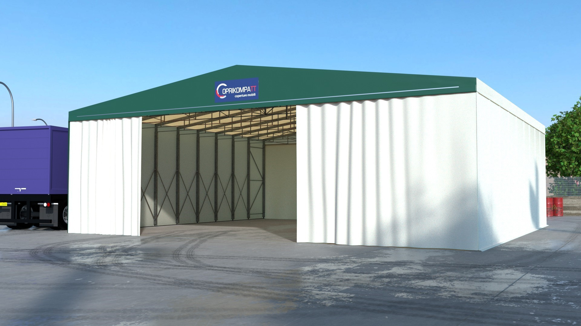

The COPRITUTTO® marquee, standard model, is a self-supporting retractable structure composed of pairs of uprights

above which are fixed trusses by means of plates bolted with type 8.8 bolts and nuts. The uprights in sturdy tubular steel slide on a rail with Sigma profile, also galvanized, configured with special wings to prevent derailment and lifting of the structure. The rails are fixed to the ground on concrete curbs, by and at the expense of the customer, or with adequately sized dowels, where there is a sturdy concrete floor, which the customer will have taken care to verify if it meets the technical specifications communicated by the manufacturer. Between the uprights, which have a variable centre distance depending on the loads involved in the installation area, there are galvanised profile pantographs, which slide on them by means of a system specially designed by Coprikompatt engineers. During the sliding of the mobile structure, the specifically designed pantographs prevent derailment or misalignment of the trusses, ensuring the possibility of manual packing until the best possible packing size is obtained. The tension of the Coprikompatt mobile shed is guaranteed by the presence of sturdy certified bands with a breaking load of up to 5 tons per traction, which can be released by a single operator with minimal effort if necessary. The surface treatment of the steel used for the construction of COPRITUTTO® mobile sheds is hot-dip galvanizing that guarantees full penetration of the molten zinc to protect all the structural elements that make up our products. To ensure the ease of use of the COPRITUTTO® mobile sheds, Coprikompatt uses wheels specifically designed for use with a diameter of 120 mm and with the help of a double ball bearing that guarantees the absence of dust and liquids that could affect its operation. The tropicalized steel wheels with special alloy guarantee the ease of use of our sheds at any time. To complete the supply of the standard mobile shed, there is the cover sheet for which Coprikompatt technicians have studied a unique formula together with the supplier of the raw material. Coprikompatt uses only fabrics of European origin certified tear-resistant with the Rachel formula of blocked knit and matte matte coating which also gives a touch of elegance to our applications. The Rachel type fabric is a particular anti-tear fabric, the Coprikompatt also joins the fabric to the structure by means of a double system of plates welded to the fabric and tension and sealing belts, tested in the laboratory with load and break tests for which they are certified. Coprikompatt produces both the structure and the fabric that covers it in its factories to guarantee the materials used.
NOTE

CALCOLI E NORMATIVE DI RIFERIMENTO
The metal structure will be checked for wind and snow and earthquake according to the regulations in force in relation to the installation area. The structural calculation report is rendered to the customer at no extra charge. It is the responsibility of the customer to present the permits to the competent bodies. Compliant with eurocode.

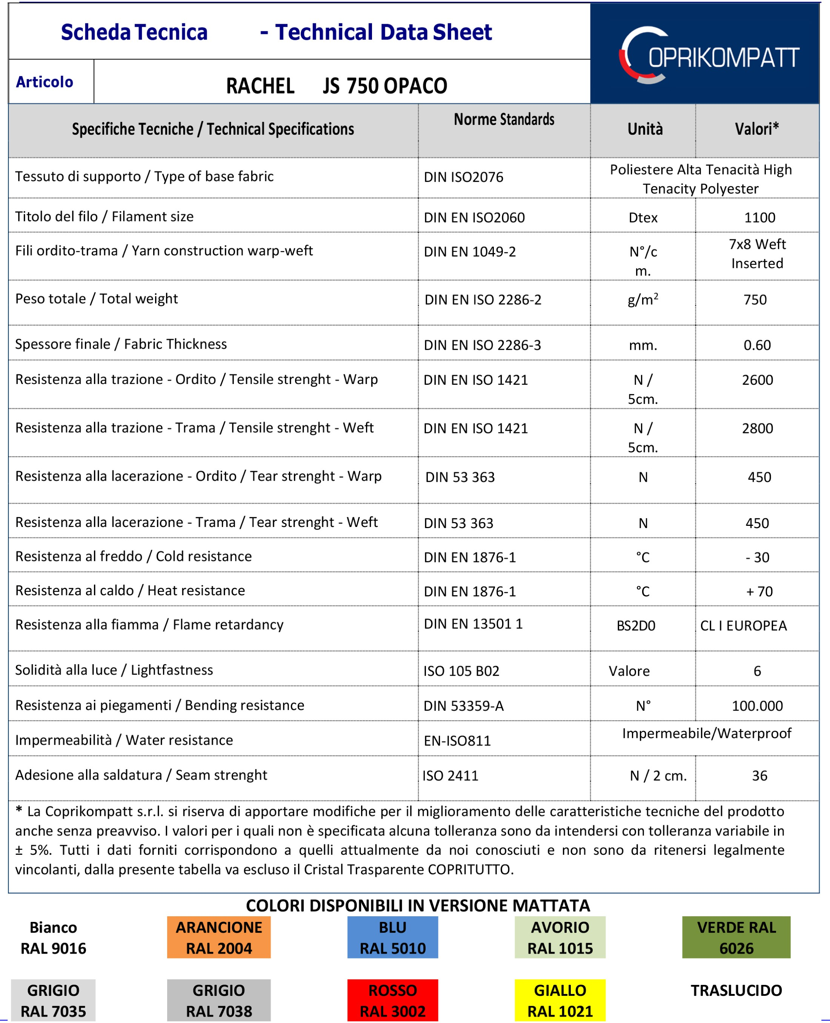

OFFERTA ECONOMICA
Immagine Codice Descrizione Quantità Listino Sconto Prezzo

CTS SELF-SUPPORTING MOBILE COVER CTS 20000x50000x6500
1 € 110.000,50

TNDFR TENDE FRONTALI 2 € 8.317,50
TOTALE FORNITURA € 118.318,00

Description | Specific
Surrender | Ex-Yard (if listed)
Delivery time | 90 working days date of approval of drawings, not before 30 days date of completion of foundations with your written communication
Installation | none
Payment | 50% deposit on order, balance on delivery with B.B.
Offer validity | 30 gg.
Packaging | Included in the price
Description | Specific
Surrender | Ex-Yard (if listed)
Delivery time | 90 working days date of approval of drawings, not before 30 days date of completion of foundations with your written communication
Installation | As per detail
Payment | 50% deposit on order, balance on delivery with B.B.
Offer validity | 30 days.
Packaging | Included in the price
Lifting equipment | Excluded

- Premise. These general conditions are an integral and substantial part of all sales contracts (commercial offer) prepared by Coprikompatt s.r.l. All the clauses below are mandatory, unless expressly and/or otherwise agreed in the commercial offer. These general conditions are considered accepted by the Client, even if they differ from any general or particular conditions of purchase prepared by the Client. Any condition inserted by the Client in the order proposal that differs from those contained in this document has no effect unless expressly accepted by Coprikompatt s.r.l. in the commercial offer.
- Prices and quotes. All amounts included in the commercial offer are net of VAT and the validity of each offer is 30 calendar and consecutive days from their receipt. If the terms assigned for the acceptance of the offer have expired, without success, the same will be considered as cancelled without the obligation of further communication.
- Payments. If there is no specific agreement between the s.r.l. Coprikompatt and the Customer, payment is understood to be made under the following conditions: 30% of the total amount at the time of signing the order, 30% upon notice of goods ready by direct remittance, balance upon delivery of the material before unloading. In the event of order cancellation, the deposit will be retained as consideration for preliminary studies preparatory to the construction of the work.
- Commercial Offer. Following receipt of the order by the Customer, Coprikompatt undertakes to draw up and send the Customer the commercial offer where all the conditions (price, payment methods, delivery times, charges to be borne by the Customer, etc.) with reference to the original order will be indicated. The acceptance of the commercial offer must be sent to the limited liability company. Coprikompatt by certified e-mail stamped and signed by the Client, in the person of the legal representative, for the purpose of concluding the contract. With the receipt of the commercial offer prepared by the s.r.l. Coprikompatt and signed by the Client together with the payment of the first agreed deposit, the agreed delivery times will begin to run. The commercial offer must be accepted without variations. If there are changes, they will be the subject of a new commercial offer that will have the same process as the previous one. Coprikompatt reserves the right to cancel the commercial offer by means of a specific written communication, even after its acceptance.
- Object of the supply. The supply includes only what is indicated in the order confirmation of Coprikompatt srl. The measures mentioned are indicative; the final ones will be those resulting from the drawing for approval that will be sent after the execution of the survey, following which Coprikompatt reserves the right to modify the proposal/order confirmation. Any other supply or service, possibly requested by the customer, will be the subject of a new offer and order confirmation following the procedure provided for in point 4.
- Delivery time. Delivery times can never be considered as essential terms for the Client for the purposes of Article 1457 of the Civil Code and will start, in any case, from the receipt of the commercial offer duly signed by the Client together with the payment of the first agreed deposit. If the commercial offer undergoes variations/modifications/interruptions/suspensions during the course of work not attributable to Coprikompatt s.r.l. (e.g. delays in sending the approval of the drawings by the Client or technicians appointed by him, strikes, difficulties in finding raw materials or delays by suppliers, variations in progress by the Client, etc.), no compensation and/or application of penalties may be claimed by the Client to the detriment of the s.r.l. Coprikompatt. If an order has multiple products with different delivery times, the longer delivery date will be taken into account. In the case of separate or deferred deliveries, the customer must notify Coprikompatt srl of any new needs, determining the calculation of a higher cost determined by the different transports.
- Criminal. the penalty clauses, as provided for by Article 1382 of the Italian Civil Code and following, regardless of what is indicated by the Client in the proposed order, must be expressly accepted by Coprikompatt s.r.l. and reported in the commercial offer. No penalty or compensation is due to the customer for damages suffered or suffered due to the extension of the agreed delivery terms, unless expressly provided, agreed and signed in the commercial offer.
- Forfeiture of penalty clauses. In the event of a commercial offer with acceptance of penalty clauses, as provided for by Article 1382 of the Civil Code and following, the liability of Coprikompatt s.r.l. will be excluded if the non-performance or delay has depended on facts/events/circumstances not attributable to Coprikompatt s.r.l. and in any case where the Customer is in default/delay with respect to the agreed payments.
- Approval of drawings. In the case of an order for products belonging to the categories of mobile covers, fixed covers, closures and tarpaulins, Coprikompatt will forward to the Customer the general drawings of the same, which must be approved by the Customer through the affixing of the stamp and signature of the administrator, within 7 working days from receipt of the technical report. With the approval of the preliminary drawings, the s.r.l. Coprikompatt will be able to follow up on the production of the commissioned work. Failure to comply with the above terms, i.e., failure to send to the s.r.l. Coverkompatt of the approval of the drawings in the following 7 days to the request for approval may result in the postponement of production times and, therefore, of delivery times which will therefore be attributed exclusively to the customer. Failure to send the approval of the drawings after the deadline of 30 calendar days from the receipt of the approval form will result in the cancellation of the economic offer and the price already paid by the Customer will be retained by the limited liability company. Coprikompatt as a penalty/compensation for damages.
- Technical inspection. Any request for a technical inspection must always be specified by the Customer at the time of ordering, failing which the goods will be prepared according to the indications contained in the commercial offer and any problems, of any kind, will be attributable exclusively to the Customer.
- Suspension of supply. The supply may always be suspended by Coprikompatt s.r.l. if the Customer's financial conditions change pursuant to Article 1461 of the Civil Code. The supply will also be suspended where the building works have not been carried out by the Client, i.e., carried out in a manner that does not comply with the installation of the commissioned structure, as well as where the Client has not obtained the administrative authorizations from the Municipal Bodies in charge, for the installation of the commissioned structure.
- Suspension of production activity due to late payments. Compliance with the delivery terms presupposes the fulfilment of contractual obligations by the Client, in particular, the payment of advances and the payment of all suspended and expiring invoices. Coprikompatt s.r.l. will therefore have the right to suspend production and/or delivery activities, without prior notice, in the event of late payments by the Customer.
- Void of warranty. If the Client does not comply with every single payment term agreed in the commercial offer, the same will be forfeited from the warranty for defects and defects of the commissioned work. The s.r.l. Coprikompatt will not be liable for defects, defects or lack of quality of the goods ordered where deriving from: a) improper use of the goods by the customer, b) repairs, tampering or modifications made to the goods, without the prior written consent of the limited liability company. Coprikompatt, c) negligence or inexperience of the Client or d) normal wear and tear, poor or insufficient storage or maintenance of the goods.
- Use of materials. Coprikompatt S.r.l. is not liable for damage to property or persons due to improper or different use of the installed products.
- Charges to be borne by the Client. The Client, at her own care and expense, must delimit the area subject to the installation of the commissioned good, freeing it from people and things. The Client, at its own care and expense, must guarantee the supply of electricity as well as the related arrangements for the connection of the equipment necessary for installation. The Client, at its own care and expense, must guarantee the provision of a forklift, of the characteristics indicated by the Coprikompatt s.r.l., for the entire duration of the assembly. The Client, at her own care and expense, must take charge of any building work (bases/foundations

and/or flooring etc) necessary for the installation/installation of the commissioned work. The Client, at her own care and expense, will have to take charge of the rainwater channeling works. The Client, at her own care and expense, must be responsible for obtaining all the necessary authorizations for the installation of the commissioned work by the public bodies in charge and must notify the s.r.l. Coprikompatt, with 20 calendar days' notice before the installation of the commissioned structure, the outcome of the authorization process. The Client, at her own care and expense, must ensure the availability of the materials to be installed near the construction site, ensuring easy maneuverability.
- Additional charges to be borne by the Client. Coprikompatt s.r.l. will be entitled to compensation for damages, as well as reimbursement of the installers' board and lodging, for the hours/days of site downtime due to interruptions attributable to the Customer deriving from delays due to the failure to make the forklift available, the failure to supply electricity and related arrangements for the connection of the equipment necessary for installation, the presence of unauthorized things or people in the installation area, problems with the handling of materials by the installers as they are not located near the construction site and/or difficult to reach, the failure to carry out the building works, i.e., carried out in a manner that does not comply with the installation of the commissioned structure and the failure to obtain administrative authorizations from the relevant bodies.
- Clause limiting the possibility of proposing exceptions. The Client, pursuant to Article 1462 of the Civil Code, may not raise exceptions, not even the exception of total non-compliance, in order to avoid or delay the payment of the price.
- Forfeiture of the benefit of the term. In the event of non-payment of even a single instalment, the buyer will automatically forfeit the benefit of the terms granted and Coprikompatt s.r.l. will be authorized to take immediate action for the recovery of the full credit claimed by it, to be considered therefore totally expired.
- Condensation: The presence of condensation is not to be considered a manufacturing defect.
- Retention of title: The ownership of the property is acquired by the Client with the payment of all instalments of the price in accordance with Article 1523 of the Civil Code. In the event of non-compliance by the customer, the same will be required to pay in favor of the s.r.l. Coprikompatt an occupancy fee of € 350.00 (three hundred and fifty /00) per day as long as the non-compliance continues, i.e., until the agreed price has been paid in full.
- Exclusive jurisdiction: For any dispute that may arise relating to the interpretation, execution and termination of this contract, the Court of PESCARA shall have jurisdiction, expressly waiving the jurisdiction of the parties to any other venue.

PER ACCETTAZIONE (timbro e firma) DATA

In compliance with article 1341 of the Italian Civil Code and following, the Client declares by signing that it has carefully read all the clauses above referring to these "General Conditions of Purchase for the supply of goods and services", and in particular that it specifically approves those referred to in articles: 4 (Commercial offer), 6 (Delivery times), 7 (Penalties), 8 (Forfeiture of penalty clauses), 9 (Approval of drawings), 11 (Suspension of supply), 12 (Suspension of production activities), 13 (Forfeiture of warranty), 15 (Charges borne by the Customer), 16 (Additional charges borne by the Customer), 17 (Limitation of liability clauses), 18 (Forfeiture of the benefit of the term), 19 (Condensation), 20 (Retention of title), 21 (Exclusive jurisdiction).

PER ACCETTAZIONE (timbro e firma) DATA

I give consent I deny consent
"We inform you that the data collected will be used to:

follow up on the information requests provided for in the existing contract;
to send you commercial communications and/or advertising material on products or services offered by the Data Controller, and to survey the degree of satisfaction with the quality of the services;
send you commercial and/or promotional communications from third parties whose services are connected with those offered by the Data Controller.
follow up on the information requests provided for in the existing contract;
to send you commercial communications and/or advertising material on products or services offered by the Data Controller, and to survey the degree of satisfaction with the quality of the services;
send you commercial and/or promotional communications from third parties whose services are connected with those offered by the Data Controller.

PER ACCETTAZIONE (timbro e firma) DATA

